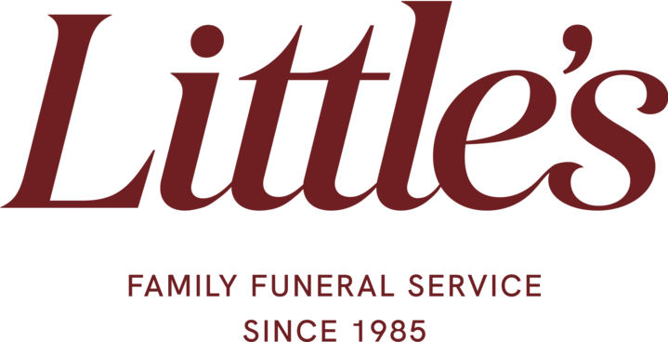

Ashes Policy for Little's Funeral Service
At Little's Funeral Service, we are committed to providing families with compassionate support in handling cremated remains. If requested, we can assist in collecting and securely storing the ashes of your loved one on your behalf. Please review the following terms regarding our handling of cremated remains:
- Collection of Cremated Remains:
Upon request, we will collect the cremated remains of your loved one from the crematorium and store them securely in a locked cupboard at one of our offices, either at 316 Clarkston Road or 2174 Paisley Road West.
- Storage Period:
Cremated remains will be stored safely for up to 6 weeks following the funeral service. After this period, the family must arrange for collection. We are unable to store ashes for longer than this unless agreed upon in exceptional circumstances.
- Collection Procedure:
The cremated remains can only be collected by the individual who signed the A1 Crematorium Form (the client). If the client is unable to collect the ashes personally and wishes to send someone else, the following conditions must be met:
  - The client must provide written confirmation of the individual who will be collecting the ashes on their behalf.
  - The designated individual must present photographic identification (e.g., passport, driver’s license) upon collection.
- Terms of collection:
If the designated individual does not bring the required identification, or if no written confirmation from the client has been provided, we will be unable to release the cremated remains.
We understand that this is a sensitive matter and aim to handle all requests with care, respect, and security. If you have any questions or need further assistance, please do not hesitate to discuss with your funeral director.
Thank you for your trust in Little's Funeral Service.
Kind regards,
Little's Funeral Service

